Business Process: Monetary Adjustments

Contact
Business Process Owner | Billing Operations – Billing Solutions  Contact Center
Subject Matter Expert(s) | Dustin Tacker, Maya Duarte, Michael Merris, Tina Dorsette
Key Contact | Maya Duarte, Michael Merris
Key Role | Customer Services Assistant  Customer Services Supervisor
Date Created | 4/23/2026

Business Process Overview
Monetary Adjustments are made in accordance with SMUD business needs when such adjustments are required. In addition to the application of monetary adjustments, several departments within SMUD conduct routine audits of Public Relations Adjustments (PRAJs). As a not-for-profit utility serving the interests of its customers and community, SMUD has a responsibility to maintain sound financial stewardship of its funds and resources.
A PRAJ is applied to a customer’s account to correct an error made by SMUD when the cost to remedy the error exceeds the amount to be adjusted. It may also be issued as a gesture of goodwill.
Although Monetary Adjustments are applied across several processes, the scope of this overview is presently limited to PRAJ monetary adjustments and the known associated monitoring processes within the Meter to Cash Workstream. The process begins when a PRAJ is requested and concludes when it has been applied. Subsequent auditing is then performed by the relevant departments to verify accuracy and compliance.

Business Process Assumptions, Prerequisites, Dependencies
(Assumptions pertaining to the business process)
People | - Assumptions:  - Employees are knowledgeable regarding delegation limits  - Employees are trained and familiar with how and when to perform a Public Relations Adjustment (PRAJ)  - Employees have completed Customer Services Representative training  - Prerequisites:  - N/A  - Dependencies:  - Delegation authority matrix pertaining to permissions
Process | - Assumptions:  - Able to apply PRAJ to customer accounts  - Able to access reporting for auditing PRAJ applied to customer accounts  - Prerequisites:  - N/A  - Dependencies:  - N/A
Technology | - Assumptions:  - Able to perform PRAJ  - Able to access and audit PRAJ  - Prerequisites:  - N/A  - Dependencies:  - Report Tree Item  - 2500 ZCS_Monetary_Audit report required to access PRAJ records for auditing

Process Flowchart
Monetary Adjustments Process Mapping As Is.vsdx
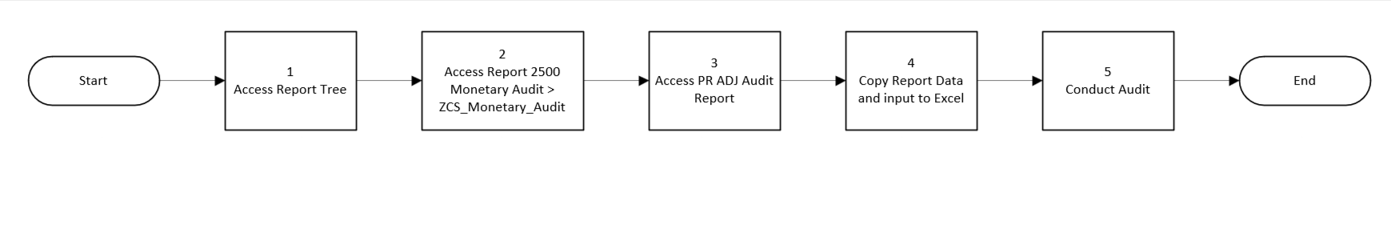

Task Description
Id | Task Description | Procedure
1 | Access Report Tree | Access ZCCS Report Tree
2 | Access 2500 Monetary Audit
3 | Access PR ADJ Audit Report | ZCCS>Credit&Collections>Monetary>2500 Monetary Audit Report> ZCS_Monetary_Audit>PR Adj Audit Report
4 | Copy Report Data and input to Excel | Copy Data from report and input to Excel workbook
5 | Conduct Audit | Audit PRAJ adjustments

Business Rules
Id | Event Name | Business Rules
 |  | See supporting document: Monetary adjustments

Event | Legal Requirements, Rules, and Regulations  Legal documents/ procedures/ requirements to be fulfilled before/at the specified event.
Id | Event | Legal Requirements, Rules and/or Regulations
 |  | N/A

Pain Points and Improvement Opportunities
Audit Monetary Adjustments (Report Tree)
- Dependent upon report tree to access data for auditing
- Report requires manual manipulation to ensure prepared for use
Public Relations Adjustment (PRAJ)
- CRM mashup to back office FPE1 which takes CSR outside of CRM

Departments impacted by process change (Required)

Department | Type of Change(s) | Action Required
Accounting* | TBD
Billing Operations | TBD
Contact Center | TBD
Revenue Assurance* | TBD

Supporting Documentation
(Any subsequent documentation in support of this business process (i.e. business requirements, technical specs, etc.) shall be summarized in the following table.)
Document Type | Link
Process Map | Monetary Adjustments Process Mapping As Is.vsdx
Business Procedures | Monetary Adjustments
Business Procedures | https://smud.my.uperform.com/PRAJ_Report
Business Procedures | https://smud.my.uperform.com/Public Relations Adjustment (PRADJ)
Business Procedures | https://smud.sharepoint.com/sites/smud-forms/Forms/2082

Business Blueprint Amendments

Any subsequent changes to this business process blueprint after the official document approval shall be summarized in the following table. This document must be reprinted and signed by the authorized representatives.
Version | Author | Description of Change | Approval (Name/Sign) | Date
1.0 | Joshua Dunn | Initial Draft | Maya Duarte | 4/23/2026

